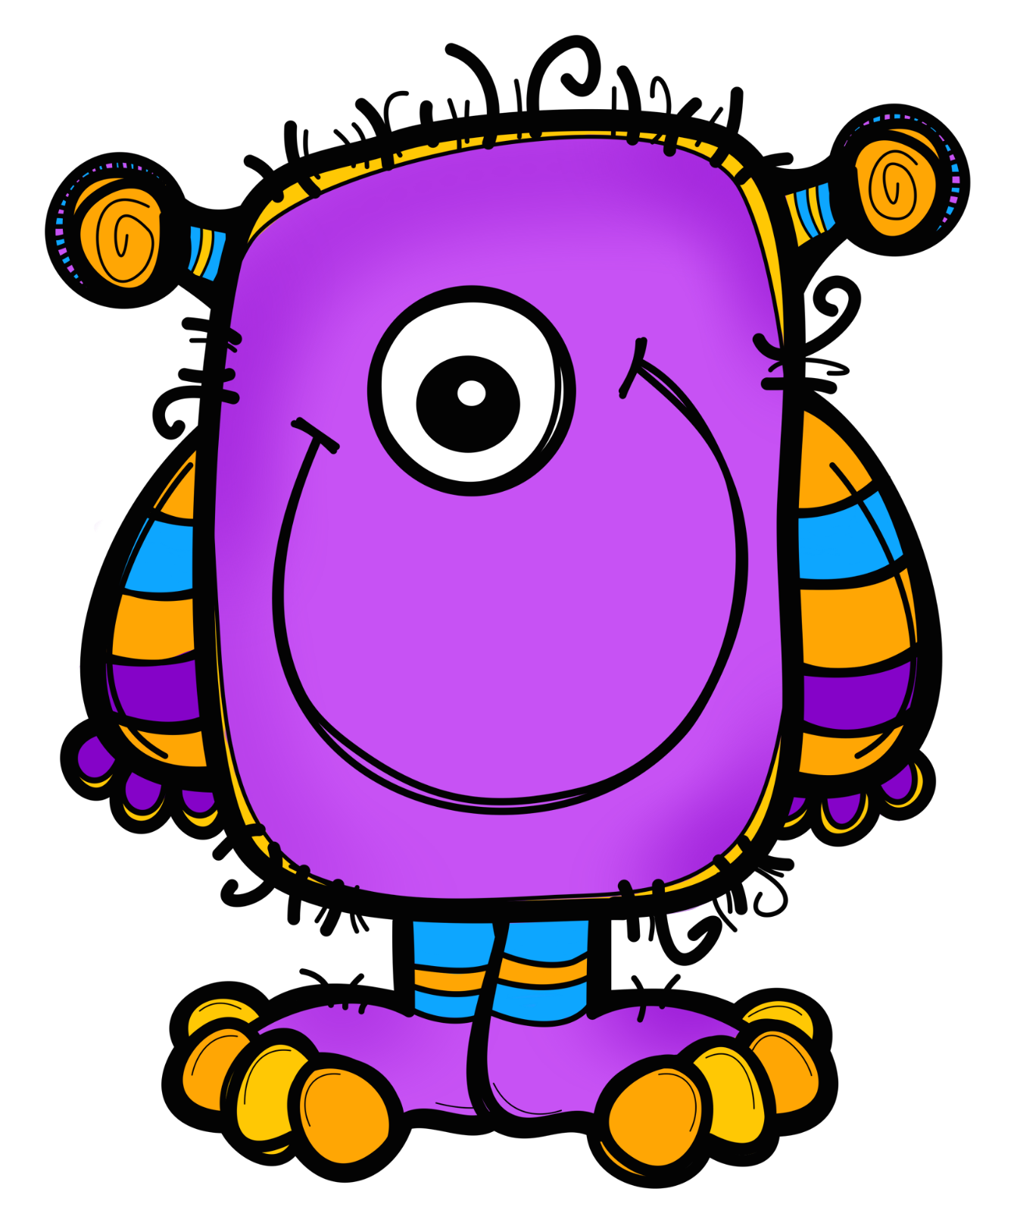
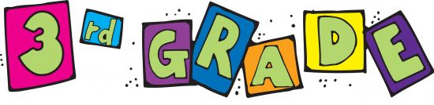
Hello and welcome
to Mount Vernon!

Congratulations – You’ve made it to 3rd grade!
3rd grade is a very busy year. You will learn a lot of new things and have a ton of fun while doing it.

Subject Areas

Reading: We will be reading new stories and novels in reading class. We will be learning new skills like fact and opinion, compare and contrast, and story plot. We love reading and will be encouraging you to read chapter books that interest you throughout the whole year.

Writing: We will continue to work on writing complete sentences. Complete sentences always start with a capital letter and end with punctuation. By the end of the year, you will be writing up to 3-paragraph essays!

Math: We will continue to improve the skills you’ve already learned in math with our NEW Envisions curriculum. Some of those skills include place value, telling time, fractions, graphs, geometry, measurement, money, addition, and subtraction (Whoa, you already know SO much) We will be starting the year off with multiplication!

Spelling: We take spelling pre-tests on Mondays and spelling tests on Fridays. You will be responsible for spelling homework throughout the week.

Grammar: We will be learning new skills and reviewing past skills that you’ve already learned. By the end of the year, you will be a grammar guru! You will be able to identify nouns, verbs, adjectives, adverbs, and so much more!

Social Studies: We will be learning about local communities, as well as communities around the world. Students will have the opportunity to research historical figures and how people in other countries celebrate Christmas! Social Studies will be taught only one half of the school year.

Science: We will be doing fun experiments throughout the year! You’ll learn about space, plants, bees and so much more! We will also get to know the Scientific Method better! Science will be taught only one half of the school year.

Things to work on this summer…

- Reading fluency (Read something every day)
- Addition, subtraction, and multiplication
- Counting coins and making change up to $1.00
- Telling time on an analog clock and figuring out elapsed time

Materials you will need to bring with you to 3rd grade

Please bring in all of the following on the first day of school (Please put the smaller items in a zip lock bag with your name on it) ~THANKS!

- Headphones (Very important/crucial for iPads)
- 3 Folders
- Highlighters (Any colors)
- 3 composition notebooks (no spiral bound notebooks)
- Scissors
- Glue Sticks (Several, please - They tend to dry out rather quickly)
- Pencil bags/boxes
- Pencils (at least 24)
- Erasers
- Markers
- Crayons/Colored pencils
- Clorox wipes
- Boxes of Kleenex
- Bottle of hand sanitizer
- Dry erase markers
- 2 black sharpies

Homework Reminder
Homework is given Monday through Thursday in both math and spelling…the students will be responsible for recording all HW in their planners. Planners will be provided around the first week of school.

We are very excited to be your 3rd grade teachers and can’t wait to see you in August. Have a safe and wonderful summer!

Mrs. Tiberio Mrs. Leuenberger Mrs. Solomon
ltiberio@efsd.net lleuenberger@efsd.net asolomon@efsd.net

